Visual Report Designer
Data Representation Ideas

===========================================================================

Sparklines
Tukey, Edward Tufte

===========================================================================
Note for future Visual Report programmers:

The point for looking into sparklines is to allow users to create a plot that can be inserted into a sentence so that the reader gets an instantaneous visual snapshot of what you are describing textually. Given that, you would want to create a plotting system that is compact (ie, no wider than a long multi-syllabic word) and no taller than the typical height of a line of text (ie, 12 pt tall).

Implementing the whisker style plot (ie, win/lose/draw) would be relatively easy, although you would need to create a separate If/Then loop to handle a table with no borders that this kind of compact plot would require. Instead of the plus/minus or red/green symbols, you would create much narrower (eg, 2-3 pixels wide) up-tick and down-tick symbols.

Implementing the sparkline plot would be harder. You would probably need to create a separate program (maybe in C?) that would make the whole sparkline as one single GIF (or bitmap) image. Alternatively, there is a way to create images through hexadecimal values when they are included as email attachments using the MIME protocol (?) and if you can decipher what the hex value would be you could just string the hex values together to create the image.
===========================================================================
Background

http://www.edwardtufte.com/bboard/q-and-a-fetch-msg?msg_id=0001OR
This master thread presents excerpts from the sparkline chapter in Beautiful Evidence on the theory of sparklines along with many many examples of the best recent work, as well as extensions of sparklines developed since Beautiful Evidence was published.
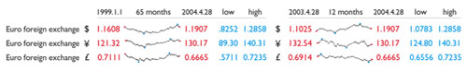

Typography: Try Verdana or Gill Sans adjusted for computer screen.

http://www.edwardtufte.com/bboard/q-and-a-fetch-msg?msg_id=0000Lk
Sparklines: computer code implementation

 | 5-Year | Close | High | Low
Cisco |  | 19.55 | 80.06 | 8.60
EMC |  | 13.05 | 101.05 | 3.83
Sun |  | 5.09 | 64.32 | 2.42
Oracle |  | 13.01 | 43.31 | 7.32

=================================================================

http://agiletesting.blogspot.com/2005/04/sparkplot-creating-sparklines-with.html
The Lakers' 2004 season was their last with Shaq, when they reached the NBA finals and lost to Detroit (note the last 3 losses which sealed their fate in the finals).

================================================================

http://chicago.everyblock.com/crime/locations/neighborhoods/
we used web standards -- regular HTML markup and CSS stylesheets -- to achieve these displays. They aren't images or Flash or other technologies. They're also "semantically-rich": in other words, if you do a "view source" on the HTML, you can see the individual data points for each statistic (also viewable if you disable styles in your browser). This allows users of the site to get both the visual view of the data in a compact and efficient way and also drill-down into the raw data points if they wish to investigate further.

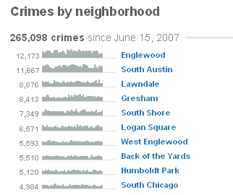
NOTE to self: This is done like SurveyMonkey. Vertical bars, set next to each other, are scaled from 0% height to 100% height.

=========================================================================

http://www.bonavistasystems.com/ChartGallery%20Column%20Charts.html
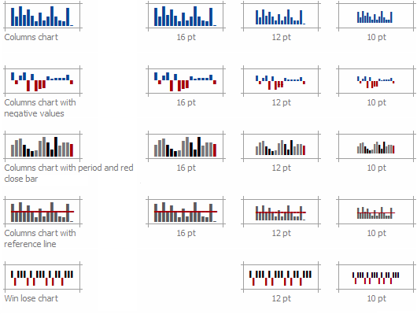

=======================================================================

http://www.bissantz.de/sparkmaker/index_en.asp
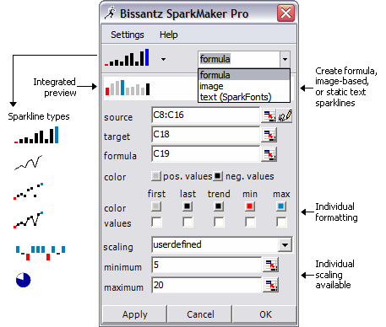

Single-color | Multi-color

=========================================================================
See http://blog.bissantz.com/bundesliga-0607
We have summarized the very exiting soccer season 2006/2007 using a straight-forward whisker style visualization.
R | Team | GP | W | D | L | Goals | GD | P | Record
1 | VfB Stuttgart | 34 | 21 | 7 | 6 | 61:37 | 24 | 70
2 | Schalke 04 | 34 | 21 | 5 | 8 | 53:32 | 21 | 68
3 | Werder Bremen | 34 | 20 | 6 | 8 | 76:40 | 36 | 66
4 | Bayern München | 34 | 18 | 6 | 10 | 55:40 | 15 | 60
5 | Bayer Leverkusen | 34 | 15 | 6 | 13 | 54:49 | 5 | 51
6 | 1. FC Nürnberg | 34 | 11 | 15 | 8 | 43:32 | 11 | 48
7 | Hamburger SV | 34 | 10 | 15 | 9 | 43:37 | 6 | 45
8 | VfL Bochum | 34 | 13 | 6 | 15 | 49:50 | -1 | 45
9 | Borussia Dortmund | 34 | 12 | 8 | 14 | 41:43 | -2 | 44
10 | Hertha BSC Berlin | 34 | 12 | 8 | 14 | 50:55 | -5 | 44
11 | Hannover 96 | 34 | 12 | 8 | 14 | 41:50 | -9 | 44
12 | Arminia Bielefeld | 34 | 11 | 9 | 14 | 47:49 | -2 | 42
13 | Energie Cottbus | 34 | 11 | 8 | 15 | 38:49 | -11 | 41
14 | Eintracht Frankfurt | 34 | 9 | 13 | 12 | 46:58 | -12 | 40
15 | VfL Wolfsburg | 34 | 8 | 13 | 13 | 37:45 | -8 | 37
16 | 1. FSV Mainz 05 | 34 | 8 | 10 | 16 | 34:57 | -23 | 34
17 | Alemannia Aachen | 34 | 9 | 7 | 18 | 46:70 | -24 | 34
18 | Bor. M'gladbach | 34 | 6 | 8 | 20 | 23:44 | -21 | 26
R = Rank, GP = Games Played, W = Win, D = Draw, L = Loss, GD = Goal Difference, P = Total Points.
=========================================================================

